To clone a GitHub repository to your local computer, follow these steps:

1. **Open GitHub Repository**

* Go to the GitHub repository you want to clone.
* You should see a page like this:

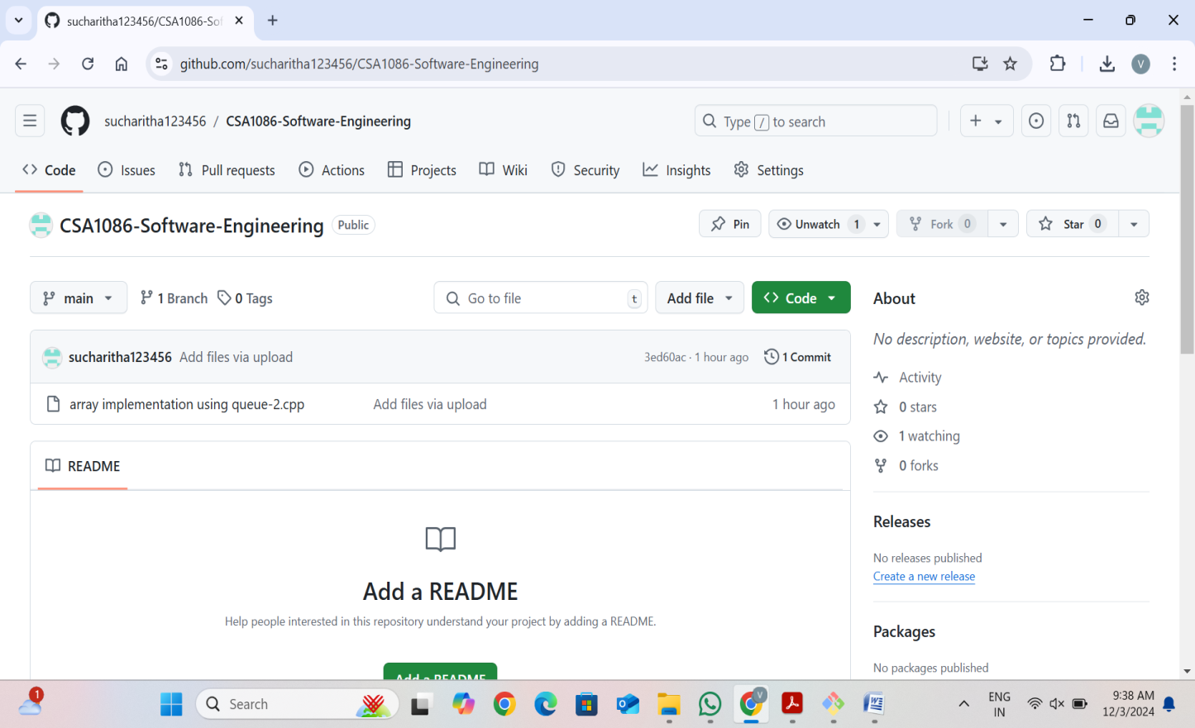

1. **Find the Clone Button**

* On the repository page, find the **"Code"** button on the right side (above the file list).

1. **Copy the Clone URL** 
   * After clicking the "Code" button, you'll see the clone options. You can clone using HTTPS, SSH, or GitHub CLI.
   * For now, copy the **HTTPS URL** (it will look like https://github.com/username/repository.git). Click the copy button next to the URL:

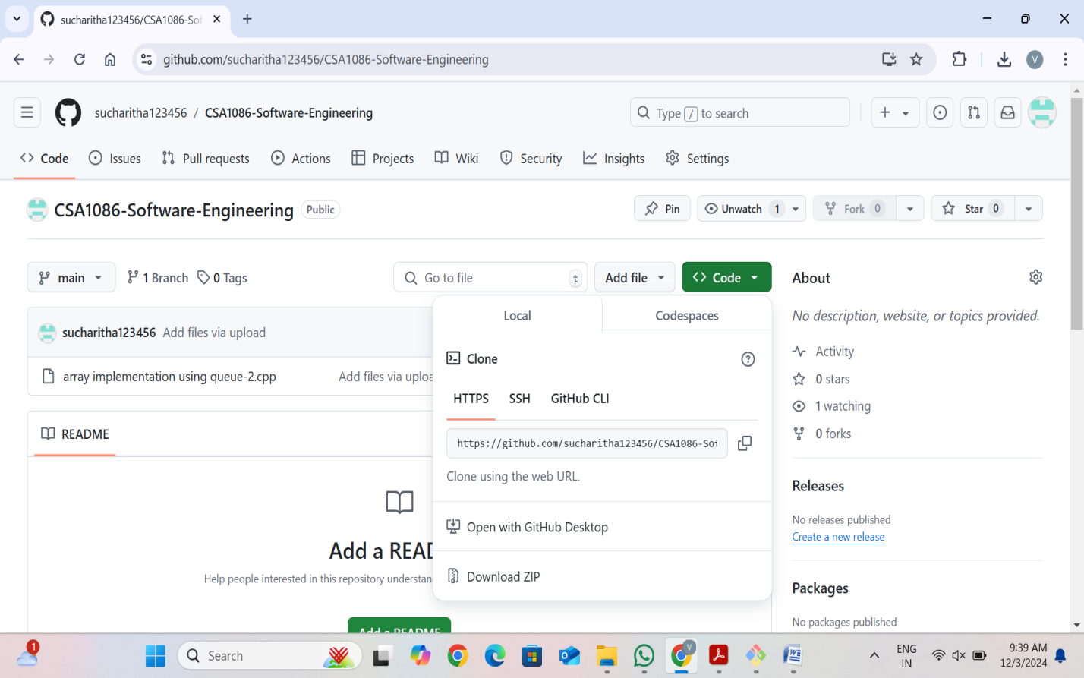

1. **Open Your Terminal/Command Prompt**

* Open your **Terminal** on macOS or Linux, or **Command Prompt** on Windows.
* You can also use **Git Bash** (a terminal that comes with Git).

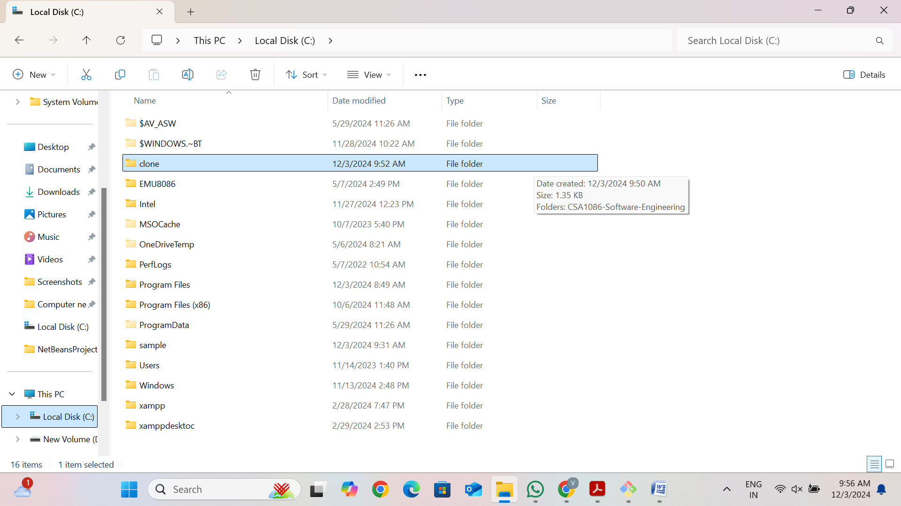

**5. Navigate to the Folder Where You Want to Clone the Repo**

* Use the cd command to navigate to the directory where you want to clone the repo.
* For example, to go to the "Documents" directory, use:
* cd Documents

**6. Run the Clone Command**

* In your terminal, type the following command:
* git clone https://github.com/username/repository.git
* Replace https://github.com/username/repository.git with the URL you copied earlier.

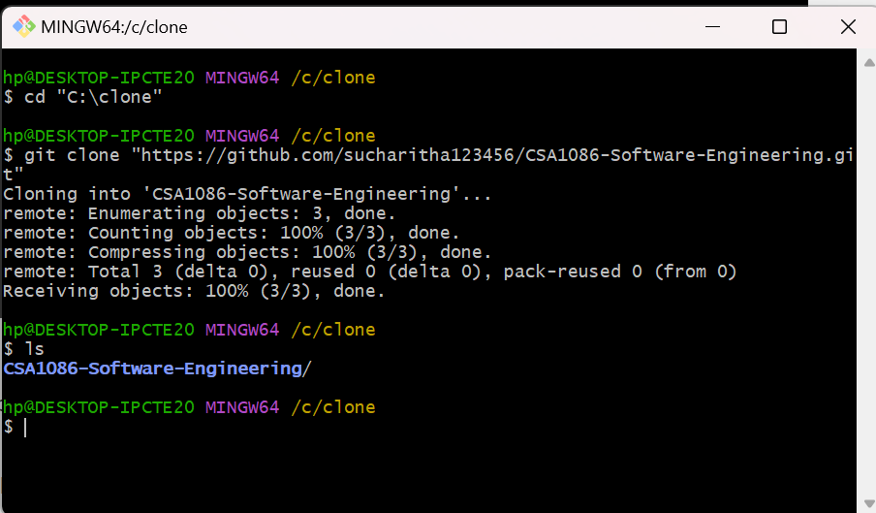

**7. Press Enter**

* Press **Enter** after typing the command. Git will now clone the repository to your local machine.

